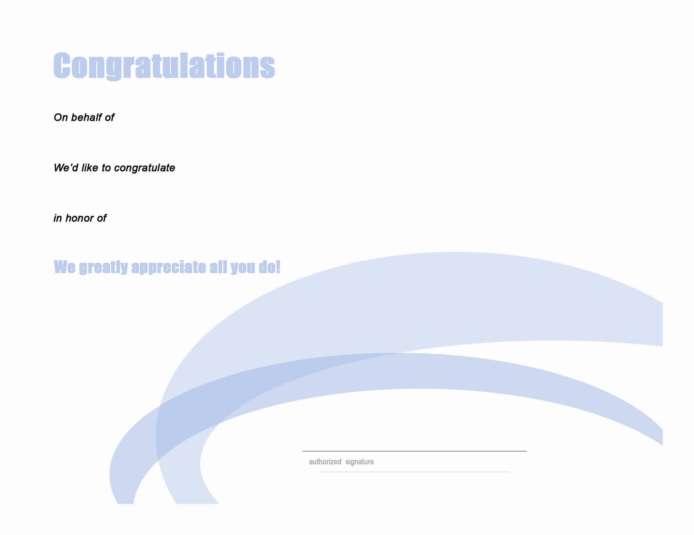

(Company Name Here)

(Recipient Name Here)

(Reason for the Recognition)

